**Department of English Language and Literature, Faculty of Humanities, Razi University**

**English Drama 17th Century-Contemporary Era**

**Spring Semester, February-June 2020.**

**Class Meeting Time:**

**Instructor:** Ghaderi, A.

**Email:** [ali.ghaderi988@yahoo.com](mailto:ali.ghaderi988@yahoo.com)

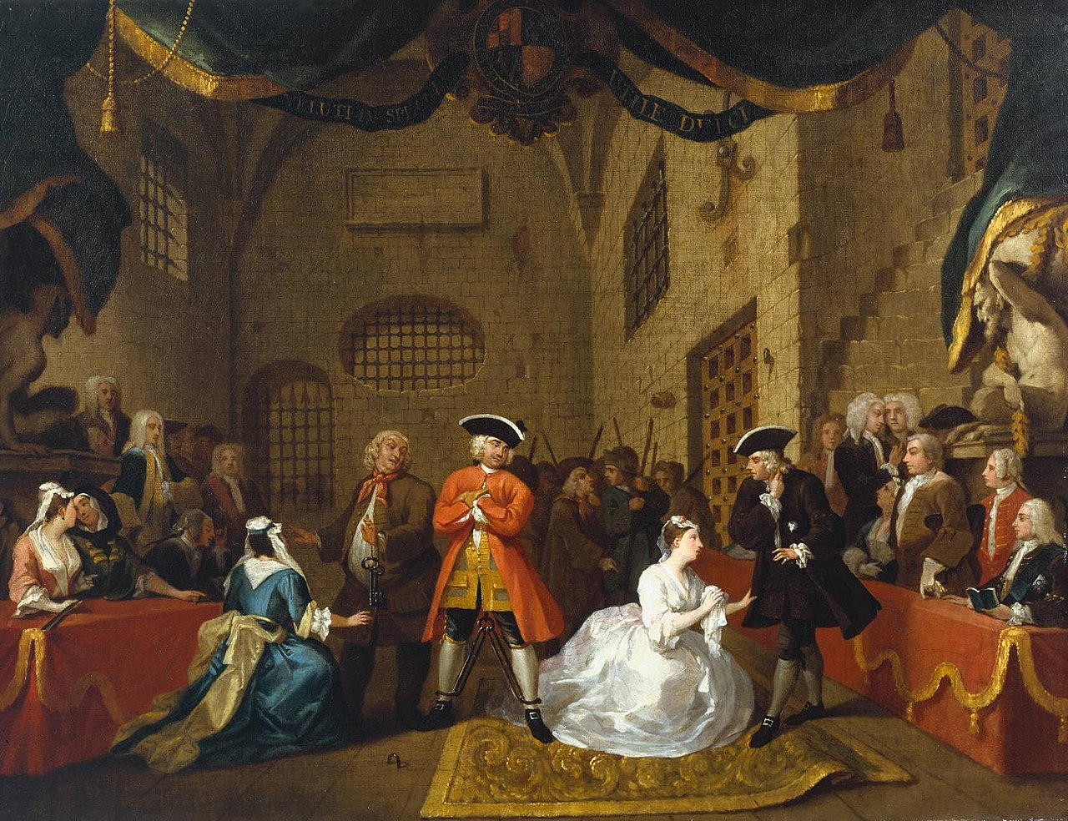

Painting based on scene 11, act 3 of *The Beggar’s Opera* by William Hogarth, c. 1728

**Course Overview:**

The drama of the land of fairies and philosophers enjoyed a golden epoch of success and triumph during the Renaissance. The fangs and claws of social philistinism and religious dogma, however, ended the joyful dance of “the finch, the sparrow, and the lark”, the oedipal hesitation of Hamlet, chaotic thirst of Faustus and bone-crushing cries of Tamburlaine on the battlefields. But new ages are underway. Drama of the society, common men, rascals and beggars was about to be born. It got philosophical more and more with each day passing into the 17th and 18th centuries. Serious questions of the social, the political and the religious were pondered upon. Censorship rose more than ever before, but nothing would stop the power of ink that is put to paper. The blood of revenge tragedies soon poured over the lands of Europe, and European tradition faced mass killings, racism, sexism, genocide and human breath becoming nothing but statistics of shattered bodies left behind on battlefields amidst barbed wires. Soon terms such as ‘a just war’ will find their way into the theater of words as they had into the theaters of wars. This is a course dedicated to explore the evolution of drama in the modern era on both aesthetic and philosophical fronts. Several plays are selected to be read and discussed during the course of this semester. You will also be given a handout in which theoretical and historical materials are provided so as to enable us to analyze the texts and the performances.

**Objectives:**

* To increase understanding of how plays mean
* To develop the ability to read and discuss modern dramas with pleasure and insight
* To develop a critical and theoretical vocabulary for the study of drama;
* To explore how drama contributed to modern culture.
* Introducing the nature and function of drama in the modern and contemporary era
* Introducing technical elements, terms and subgenres of drama
* Reading famous examples
* Introducing notable traditions and schools of drama

**Students’ Responsibilities and Required Assignments:**

* **Attendance:** Students are expected to attend all scheduled classes and to have completed the assigned reading before arriving in class. Two absences will be permitted. Each additional absence will result in a reduction of the final course grade.
* **Participation:** Students are expected to take part in class discussions and raise questions, if they have any, regarding the subject matter and content of each session. Moreover, they will be asked to give their opinion on certain matters during the class time.
* **Policies**

Attendance and participation are mandatory. Students must have the texts under discussion on them during the sessions (electronic editions and hardcopies are both acceptable). For the use of electronic editions look at classroom rules section.

The class is open to any reasonable criticism or suggestion. First and foremost, this course and our energy and time are to be employed to make sure that learning will occur, and you will finish this course with relative satisfaction having achieved a minimum though sufficient amount of literary and critical understating in accordance to your needs and interests. Hence, please share your concerns with the class or the instructor anytime the necessity arises.

**Classroom Rules**

* All electronic gadgets must be off or set to silent mode. If you use them for reading PDFs and other class related files, make sure they will not distract you or others so as to prevent the class from digressions.
* Punctuality is a non-negotiable must.
* 3 sessions of absence mean reducing your chance of passing the course greatly not to mention increasing the possibility of being dropped out of the course. Don’t try it, ever!
* Class activities are expected of the students.
* Last but not least, respect the class. Do not leave the class in groups during the breaks. You absolutely must not extend breaks’ duration on your own authority. For each session, a 10 minute break is already scheduled.
* Should the students have any questions, concerns, or requests for meeting and materials, they will contact me **only and solely** via my email address. Other forms of communications are absolutely not recommended.

You all have my thanks and appreciation since you have always observed these rules and regulations during your presence at classes. Bringing them here again is only a matter of formality and academic regulations.

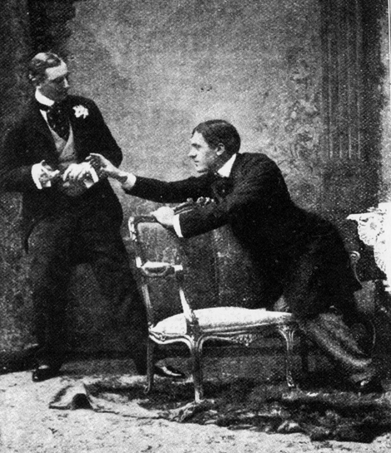

The original production of *The Importance of Being Earnest*, 1895 Allan Aynesworth as Algernon and George Alexander as John

**Schedule:**

**Session 1:**

Restoration drama, 18th century drama. Hölderlin, The Human Condition: ‘Sobriety’ versus ‘Intoxication’ and The Modern Condition: Us versus the Greeks. John Gay’s *The Beggar’s Opera* (not to be read; just discussed by the instructor).

**Session 2:**

Romanticism and Melodrama 1800-1880. Kierkegaard: Modernity and Subjectivity, The Greek Tragic Hero Freedom, Fate, Hamartia and the Tragic Effect. Richard Brinsley Sheridan’s *The School for Scandal*.

**Session 3:**

August Sternberg’s *Miss Julie* (just the introduction). Henrik Ibsen’s *A Doll’s House*. ‘The Price of Freedom’.

**Session 4:**

‘Modern Theater 1880-1945’. Oscar Wilde’s *The Importance of Being Earnest*. ‘Oscar Wilde: Aesthetics and Criticism’.

**Session 5:**

George Bernard Shaw’s *Man and Superman*. From ‘Quintessence of Ibsenism’.

**Session 6:**

Eugene O'Neill’s *The Hairy Ape*. ‘The Divided Self of American Drama’.

**Session 7:**

Postwar Theater 1945-1970. Bertolt Brecht’s *Mother Courage and Her Children*. ‘Arthur Miller’s ‘Tragedy and Common Man’.

**Session 8:**

Samuel Becket’s *Waiting for Godot* I.

**Session 9:**

Samuel Becket’s *Waiting for Godot* II. Martin Esslin from *The Theatre of the Absurd*.

**Session 10:**

‘Contemporary Theater’. Edward Albee’s *Who’s Afraid of Virginia Woolf?* (adaptation).

**Session 11:**

María Irene Fornés and Caryl Churchill: Introductions. Caryl Churchill’s *Top Girls* (performance) and *A Number*.

**Session 12:**

‘Reading Drama, Imagining Theater’. Reviewing a movie script: Graham Moore’s *The Imitation Game*.\*

**\**Attention*:** Depending on many conditions and circumstances, the content of this syllabus may change. The students will be asked to give their opinions and suggestions on this matter.

**Resources:**

Gainor, J. Ellen, Stanton B. Garner, and Martin Puchner. *The Norton Anthology of Drama*. New York: W. W. Norton & Company, 2018.

**Grading and Evaluation:**

Participation and analysis of the works on class’s agenda are expected of the students.

**Your final\*\* grade will be decided based on:**

Class participation + attendance→ 30 + 10 per cent

Final exam → 60 per cent

\*\*the final exam will be an essay exam. On your exam, you will answer essay questions that are structured around the issues discussed in the class. You must respond to them properly and to the point in a reasonable length with maximum awareness of the texts themselves and critical subject matters that have been presented in the class. It goes needless to say that those who show genuine analytical insights in their answers will receive extra points. And there will be at least one bonus question on your exam which is much more difficult than the regular questions and needs a great deal of critical insight and mastery over the sources. Don’t forget: **everything I say will be on the exam!**

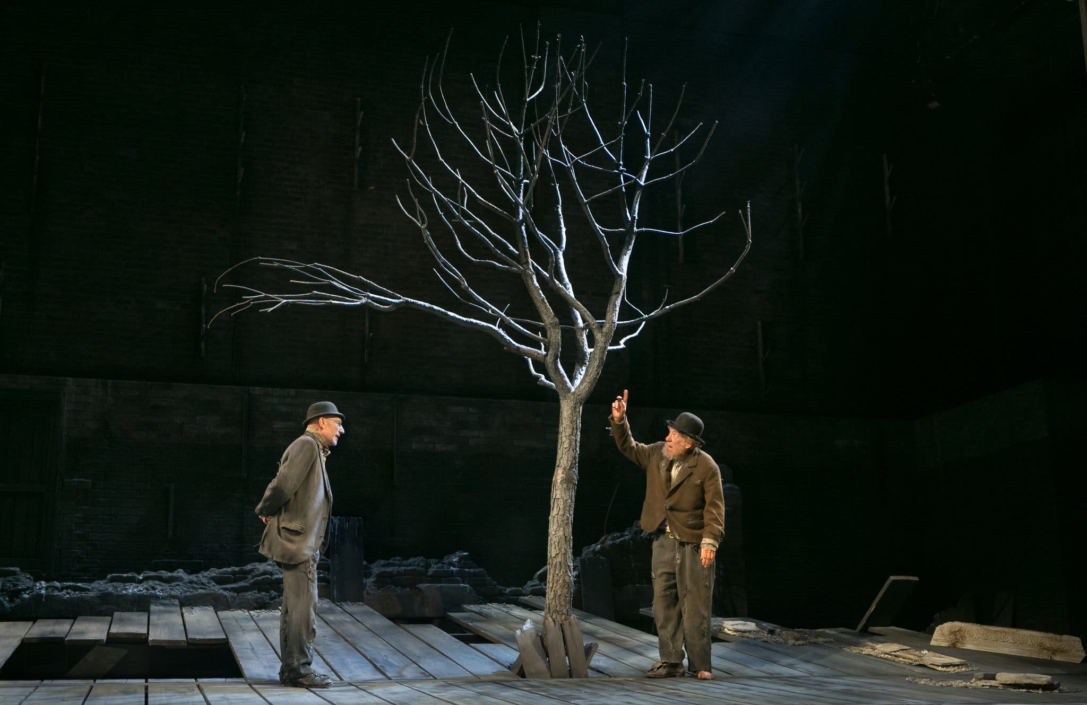

[Patrick Stewart and Sir Ian McKellen in a production of](https://www.alamy.com/stock-photo-patrick-stewart-and-sir-ian-mckellen-attend-the-press-night-for-waiting-35371840.html" \t "_blank) *[Waiting for Godot](https://www.alamy.com/stock-photo-patrick-stewart-and-sir-ian-mckellen-attend-the-press-night-for-waiting-35371840.html" \t "_blank)*