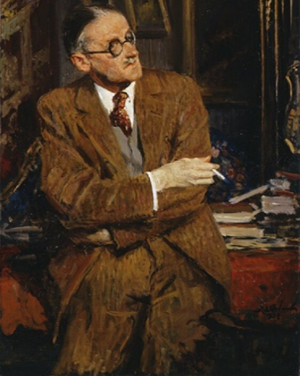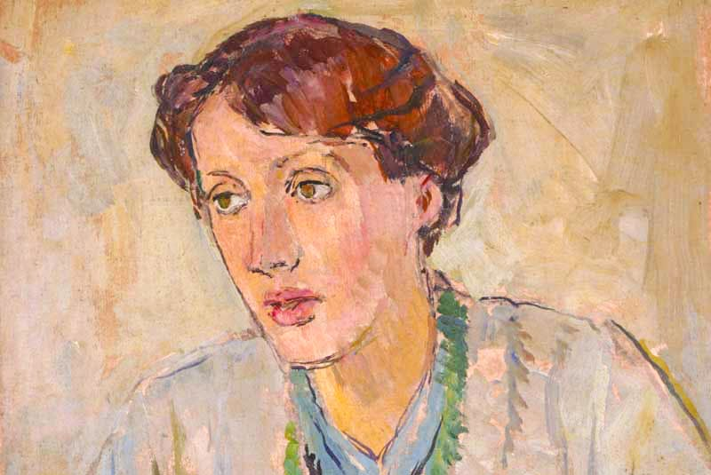
James Joyce © National Portrait Gallery, London-Virginia Woolf (detail; c. 1912), Vanessa Bell
Department of English Language and Literature, Faculty of Humanities, Razi University
A Course Syllabus for the 20th and 21st Centuries American/English Novel
Fall Semester, September 2019- January 2020.
Class Time: Saturdays, 13:30-15:30.
Instructor: Ghaderi, A.
Email: ali.ghaderi988@yahoo.com

Part 1: Course Overview
This course aims to trace the formal, thematic and aesthetic developments and changes of English and American novel in the 20th and, partly, 21st century. The course primarily will be focusing on the relationship between writers and readers, historical, cultural context, experimentality in fiction writing, innovations in the novel's form, fiction’s engagement with history and historiography, and the changing place of literature in American and English culture. Unfortunately, the reading list, due to our contracted timetable, is limited to James Joyce’s A Portrait of the Artist as a Young Man (1916) Virginia Woolf’s To the Lighthouse (1927) and Cormac McCarthy’s The Road (2006).
How have the vicissitudes of modernity led to a re-direction of historical narration within the novel; how has (post)modernist aesthetic experimentation re-shaped the very form of the novel; and lastly how has the phenomenon of imperialism, the asymmetrical relations of power between center and periphery, widened the scope of fictive milieu? These are some if the important questions that are to be addressed during this course. Since the history, and specifically history of literature, is not an inconsistent set of points and cells but a flow of constant fluctuations and interactions, the course will introduce many novelists, their works, and the critical perspectives pertinent to their style and content of writing. No literary work is created out of a void; that is why the history with all her content is so important when discussing literature or art in general.
As mentioned, the time and interest of this course are to address more than only two English and American novels. However, the instructor and students must focus on the rich merits, technicality, and content of the aforementioned texts. Moreover, in the past 50 years more and more brilliant novels are adapted into cinematic representation; some of which masterpieces worthy of high praise. We will explore this interesting aspect of novel as well to gain insight into the complex yet charming ways in which novels born out of the genius of a specific writer can both influence culture and history and be shaped by those two. Last but not least, speculative fiction, such as works of Tolkien and Rowling, and science-fiction novel, particularly those like The Road that depict a post-apocalyptic universe, have gained popularity recently, so the course will also try to address pivotal aspects of these examples as well.
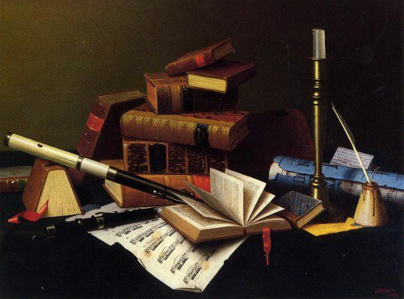
William Michael Harnett, Music and Literature
Modernism; fragments or bodies intact?
Part 2: Course Objectives/Outcomes
The quality of performance in this course is highly dependent on two pivotal factors. First, instructor’s competence, strategy and choice of reading materials. Second, student’s comprehensive close reading of the given materials. If these two are achieved, the course will be able to approximate the following outcomes:
- Student will be able to understand and critically read the texts with a heightened sensitivity to interpretations, cultural history, and aesthetic/formal features.
- Students will observe and apprehend how novels of this period reflect or even challenge ideology and conceptions of the British and American nation.
- Applications of close-reading to the given materials.
- Students’ faculty of critical thinking will grow to reach a certain level of sophistication.
- Students are expected to demonstrate an understanding of the aesthetic and social construction of novels in this period.
- An understanding and analysis of the meanings of space and place, point of view, motion, character, plot and emotions in the novels will be developed.
- As readers on the path of becoming aficionados, we will be able to appreciate the diverse histories and abilities of novelists and the ways in which they have transformed and recreated the genre of the novel.

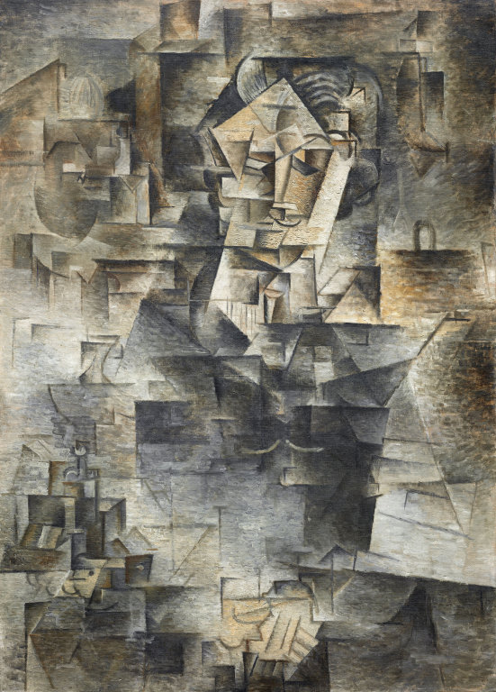
1910, Portrait of Daniel-Henry Kahnweiler, Picasso
Part 3: Required Texts
Forster, E. M. (1955). Aspects of the Novel. London: Harcourt.
Joyce, J. (2000) [1916]. A Portrait of the Artist as a Young Man. New York: Oxford.
McCarthy, C. (2006). The Road. New York: Alfred A. Knopf.
Woolf, Virginia (1992). Collected Novels of Virginia Woolf Mrs. Dalloway To the Lighthouse The Waves. London: The Macmillan Press.
Suggestions for Further Readings:
Greenblatt, Stephen, and Meyer Howard. Abrams. The Norton anthology of English literature. Vol. 1 & 2. New York, Norton & Company, 2013.
Baym, Nina. The Norton anthology of American literature. New York, W.W. Norton & Company, 2002.⃰

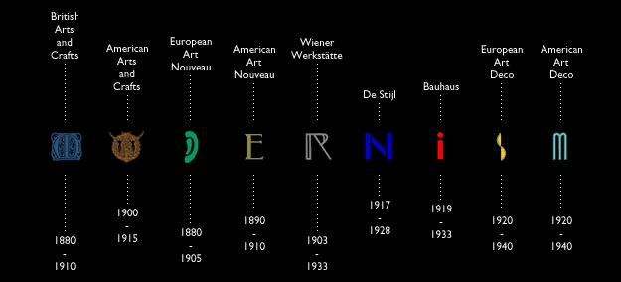
Chronological diagram of Modernism
⃰indeed more books, papers, and other materials will be mentioned during the course. Yet, these two are primary for every literature student. There will be some parts of these two’s content delivered during the course, and only a small portion of these parts are going to be on your final exam.

Homeric Po-Moe
Part 3: Method and Strategy
For the sake of clarity and illumination, the course will start with introductory lectures that will focus on theoretical aspects of the genre of novel. For this aim E. M. Forster’s classic yet pivotal text has been chosen whose intellectual content will be delivered by the instructor. It is paramount that students do not miss these sessions. Although Forster’s volume is a must-read in its entirety, for the interest of brevity some parts of it will be chosen to be presented during the sessions. It goes needless to say that students must read these selected parts. The fiction genre has gone through tremendous changes and evolutions since Forster’s volume was published. For this very reason additional information of the relevant critical, literary, and theoretical trends are to be added to the content of the class by instructor’s choice.
The quality of the course and the final grades of the students are heavily measured by their mastery over the reading materials specially the two novels chosen for the class. It is highly recommended that the students read the novels meticulously employing their faculty of critical thinking. In this regard. It is exceptionally helpful and illuminating if the students pay attention to stylistics of the novelist, devices employed by the novelists, aesthetic construction of the texts, and of course sociocultural context into which the novels were born. The art of close reading does not aim to finalize the meaning of the texts or reach a single interpretation; it opens up our mind and the texts to new and probably countless meanings and possibilities. For this to be achieved, the instructor will also introduce a few strategies to help improve students’ close readings.
The use of extra materials (critical papers, books, videos, etc.) will also be a great complementary element. However, due to course extensive reading materials, any extra item will be briefly introduced and elaborated upon on the part of the instructor. If the need arises, the instructor will provide the students with any texts or files necessary. Further, using any additional sources on the part of the students will be indeed a very fruitful event. These sources can vary from websites to books and papers. Great range of variety and infinite length of these online/offline materials can be a source of digression and distraction though. Student are advised to seek instructor’s counsel before choosing any extra source for their readings. Lastly but most importantly, the instructor strongly advises students against reading and using any form of novel summaries. It kills the pleasures of the texts and dulls your critical faculty and reason. Refrain from reading them. I cannot emphasize this last point enough.
Students must read the novels in their entirety. For class discussions, some excerpts will be chosen and the students will be informed about them so as to enable them to focus on those parts and think about them with more mental acuity (students are more than welcome to give their opinion regarding choosing these excerpts. You can give me your suggestions and I will surely take them into account). However, none must assume these excerpts are more important than the other parts of the texts or that these excerpts will be the only sources for the final exam. Approach the texts with the assumption that every words and phrases are of prime value. And remember, take notes during the sessions.
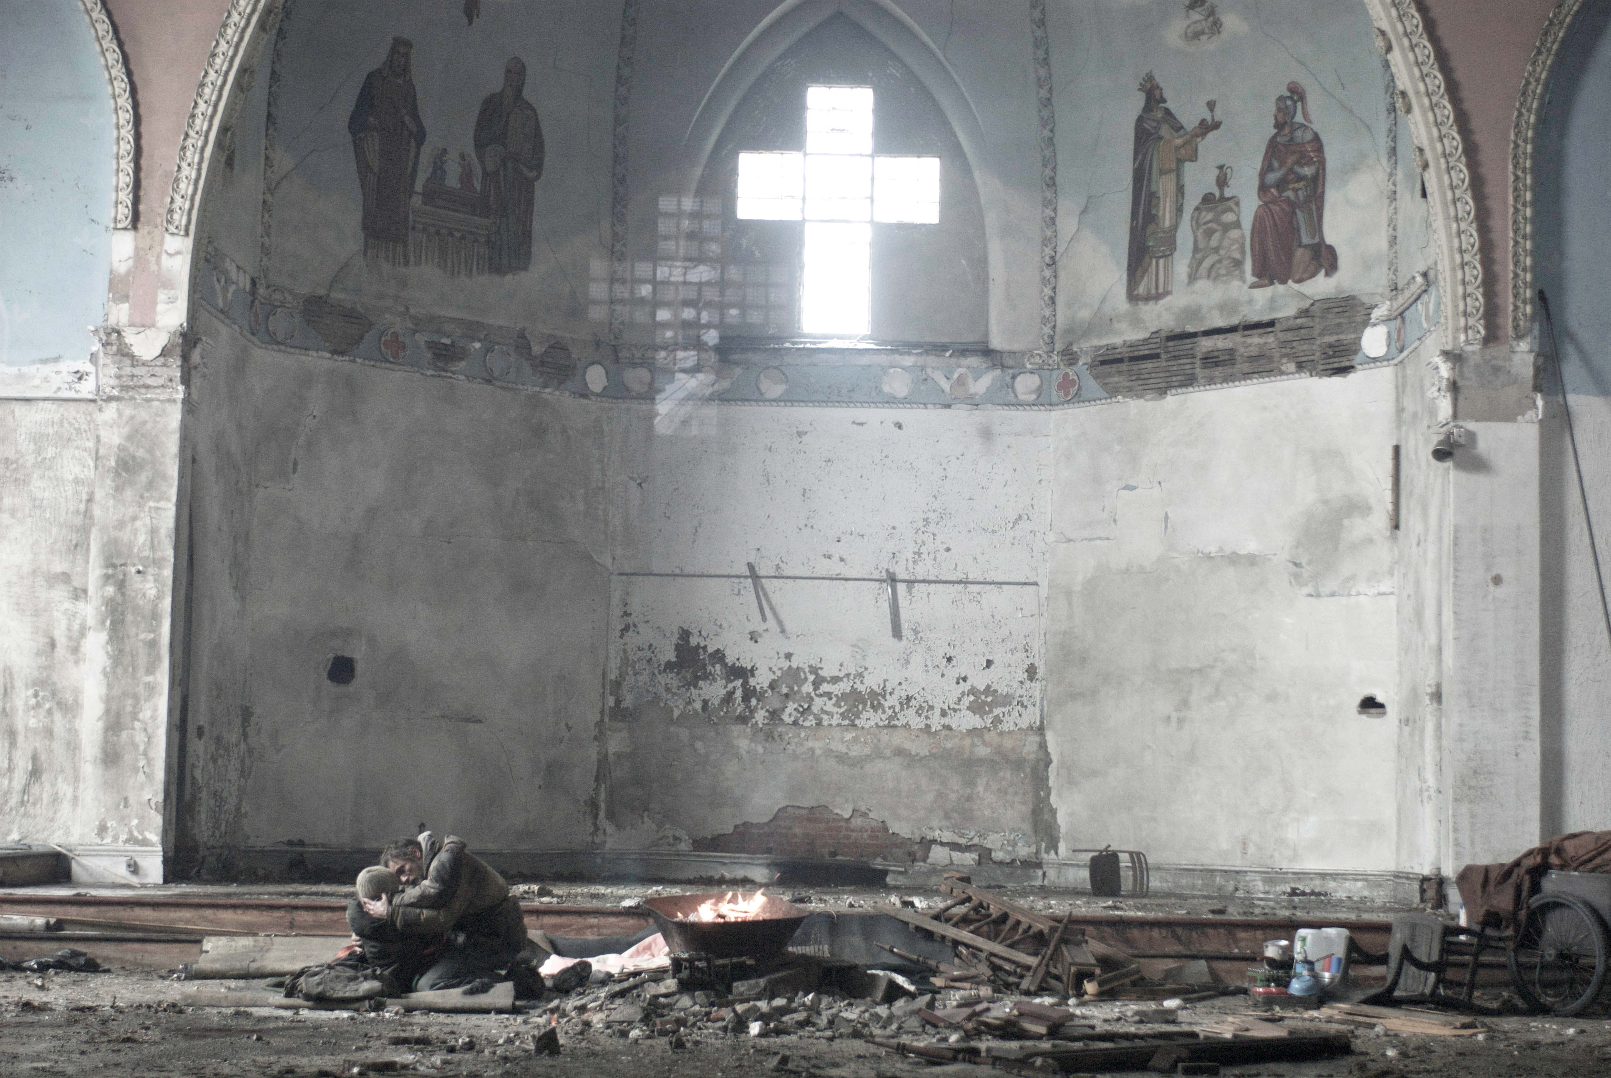
The Road (2009)
Part 4: Students’ Responsibilities and Required Assignments:
- Attendance: Students are expected to attend all scheduled classes and to have completed the assigned reading before arriving in class. Two absences will be permitted. Each additional absence will result in a reduction of the final course grade.
- Participation: Students are expected to take part in class discussions and raise questions, if they have any, regarding the subject matter and content of each session. Moreover, they will be asked to give their opinion on certain matters during the class time.
- Forum Discussion/Student-led Forums: After weeks 3 and 6 you will participate in a forum discussion around course readings and delivered lectures. Candidates must discuss specific issues assigned to forums by the instructor in groups of 4-5. Members will alternate responsibility for posting questions, reflections, reading experiences, or lessons learned from their readings. All team members will respond to the original question or reflection and email their reports to the instructor. These two forum reports must be at least 1000 words in length (Times New Roman font, size 12, double spacing with one-inch margins on all sides). But please do be notified; quality of writings matter to me not the length.
- Individual Writing Assignments: Two close reading essays (500 words each) on each of the two novels and issues discussed around Forster’s texts are required from the students. Each of these essays is due by first session after finishing discussing each novel in the class; with the exception of the essay on Forster’s texts that is due by three weeks after finishing the discussions and lectures around it. I will provide oral and written examples of close readings on each novel and Forster’s volume.
- Plagiarism: All written essays submitted in this course must be your own and written exclusively for this course. Cite every sources you use in your essay to avoid violating academic and scholarly ethics. Sources must be properly documented in MLA citation style. The rules for MLA citation will be easily found on the internet. Plus you can use the following websites:
http://www.citationmachine.net
https://owl.english.purdue.edu/owl/resource/747/24/
Please do not refrain from asking me questions if you have any regarding use of sources and citations.
- Policies
Attendance and participation are mandatory. Students must have the novels and other required texts under discussion on them during the sessions (electronic editions and hardcopies are both acceptable). For the use of electronic editions look at classroom rules section.

The class is open to any reasonable criticism or suggestion. Moreover, any objections that the assignments are too much or the sources are too lengthy or difficult for the class’s level are also welcome on the instructor’s part, but they are also to be met with meticulous scrutiny before being accepted into the lesson plan. Therefore, if you have any objections regarding this particular issue, please do think it thoroughly.
First and foremost, this course and our energy and time are to be employed to make sure that learning will occur, and you will finish this course with relative satisfaction having achieved a minimum though sufficient amount of literary and critical understating in accordance to your needs and interests. Hence, please share your concerns with the class or the instructor anytime the necessity arises.
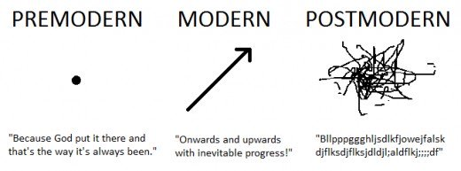

Part 5: Makeup Sessions Rules:

If necessity dictates, and based on past experiences it sure will, extra sessions will be added to our course. At this point we need at least one extra session. Time and date for extra sessions will be discussed with the students to ensure maximum rate of attendance and minimum amount of inconvenience. Decisions taken regarding this matter will be announced two weeks prior to the extra sessions.

Part 6: Classroom Rules and Standards of Online Behavior

- All electronic gadgets must be off or set to silent mode. If you use them for reading PDFs and other class related files, make sure they will not distract you or others so as to prevent the class from digressions.
- Punctuality is a non-negotiable must.
- 3 sessions of absence mean reducing your chance of passing the course greatly not to mention increasing the possibility of being dropped out of the course. Don’t try it, ever!
- Class activities are expected of the students.
- Last but not least, respect the class. Do not leave the class in groups during the breaks. You absolutely must not extend breaks’ duration on your own authority. For each session, a 10 minute break is already scheduled.
- Should the students have any questions, concerns, or requests for meeting and materials, they will contact me only and solely via my email address. Other forms of communications are absolutely not recommended.

You all have my thanks and appreciation since you have always observed these rules and regulations. Bringing them here again is only a matter of formality and academic regulations.

Part 7: Grading Policy and Final Exam Structure

Points | Description
30 | Each individual essay will determine 10 per cent of your final grade
15 | 15 per cent of your final grade will be decided based on your attendance and participation.
55 | Final exam will determine 55 per cent of your final grade⃰.
100 | Total Points Possible

⃰ the final exam will be an essay exam. On your exam, you will answer essay questions that are structured around the issues discussed in the class. You must respond to them properly and to the point in a reasonable length with maximum awareness of the texts themselves and critical subject matters that have been presented in the class. It goes needless to say that those who show genuine analytical insights in their answers will receive extra points. And there will be at least two bonus questions on your exam which are much more difficult than the regular questions and need a great deal of critical insight and mastery over the sources. Don’t forget: everything I say will be on the exam!

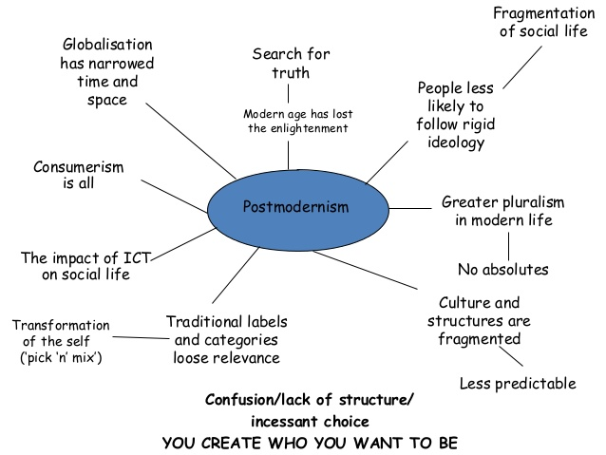

Letter Grade Table:

Letter Grade | Percentage | Description
A | 93-100% | Excellent Work
A- | 90-92% | Nearly Excellent Work
B+ | 87-89% | Very Good Work
B | 83-86% | Good Work
B- | 80-82% | Mostly Good Work
C+ | 77-79% | Above Average Work
C | 73-76% | Average Work
C- | 70-72% | Mostly Average Work
D+ | 67-69% | Below Average Work
D | 60-66% | Poor Work
F | 0-59% | Failing Work

Part 8: Schedule

Week | Topic | Readings | Activities/Assigned Time
1 | Introduction to the Course. Introduction to Novel. Definitions: What makes this Strange genre so charming and mysterious? | The Syllabus  Oxford edition’s introduction. | Introducing the Course/30 minutes. Break/ 10 minutes. Introduction to Novel, Definitions, Critical and Literary Trends, and the Aspect of Story/40 minutes.
2 | Modernist Novel: Form and Aesthetics  A Portrait | A Portrait 1-75  n | Text discussion/30 minutes. The paper/50 minutes.
3 | A Portrait of the Artist as a Young Man. Stream of Consciousness and Identity in Novel | A Portrait 76-146  Helene Cixous • [The Artist and the Law] | Text discussion/30 minutes. The paper/50 minutes.
4 | Novel, Drama of Life and Politics/Aesthetics of Modernism | A Portrait 147-224  Karen Lawrence • Gender and Narrative Voice in Jacob’s Room and A Portrait of the Artist as a Young Man | Text discussion/30 minutes. The paper/50 minutes.
5 | Introduction to Woolf and her time.  To the Lighthouse | Aesthetics and Philosophy of Woolf’s works. | Woolf and her age/40 minutes. Philosophy in Woolf/40 minutes.
6 | To the Lighthouse | To the Lighthouse 181-231  Sharon Kim • The Mirror Of Mental Ruin In To the Lighthouse | Text discussion/30 minutes. The chapter/50 minutes.
7 | To the Lighthouse | To the Lighthouse 232-282  Randi Koppen • Embodied Form: Art and Life in Virginia Woolf's “To the Lighthouse” | Text discussion/30 minutes. The paper/50 minutes.
8 | To the Lighthouse | To the Lighthouse 283-334  Rosemary Luttrell • Virginia Woolf's Emersonian Metaphors of Sight in To the Lighthouse: Visionary Oscillation | Text discussion/30 minutes. The paper/50 minutes.
9 | English and American Novel up to the Turn of the Century  Cormac McCarthy and Other Contemporary American Novelists.  The Road | The Road, pp. 3-50.  Related Parts in Both Anthologies or from any Other Suitable Sources (optional) | Postmodernism Dawn: The Question of Theory and the Genre of Fiction/30 minutes. McCarthy’s Canon in American Literary Heritage/30 minutes. Break/10 minutes. On American Great Novelists/20minutes.
10 | McCarthy’s Aesthetics and Style. Continuing the Discussion on the Contemporary English/American Novel and Introducing the Concept of Adaptation | The Road, pp. 51-101  Related Parts in Both Anthologies or from any Other Suitable Sources (optional) | Close Reading of Selected Parts with Discussing Critical Aspects/40 minutes. Break/10 minutes. Adaptation and Novel: Will Cinema Replace Textual Story Telling?/40 minutes.
11 | American Myths in McCarthy. Fiction of Speculation and the 20th Century. | The Road, pp. 102-180. | Dreams of the World as It Never Was: the Significance of Post-apocalyptic Novels/40 minutes. Break/10 minutes. On Fantasy and Our Mentality After Theory/40 minutes.
12 | Concluding Session on McCarthy’s Novel | The Road, pp. 181-241. | Close Reading of Selected Parts with Discussing Critical Insights/45 minutes. Break/10 minutes. The Condition of Novel After 2000/35 minutes.
13 | Summing-up Session. Introduction to Metafiction and the Authors of the Genre.
14 | Review

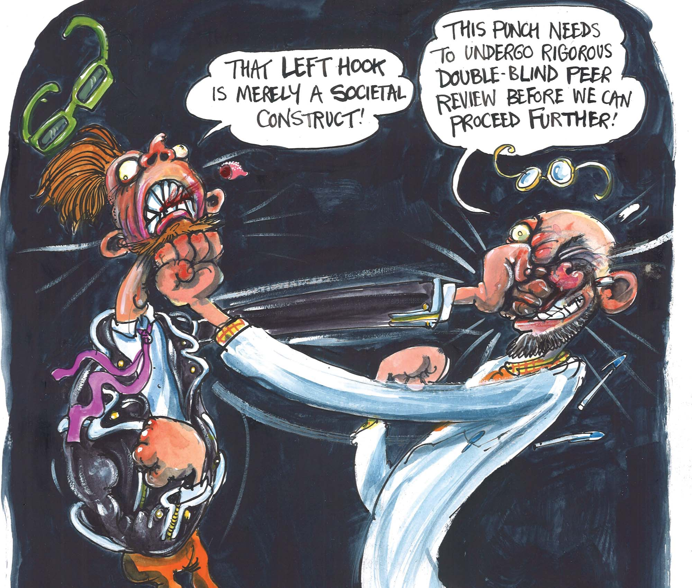

“Have postmodernist thinkers deconstructed truth?”
Cartoon by Martin Rowson

