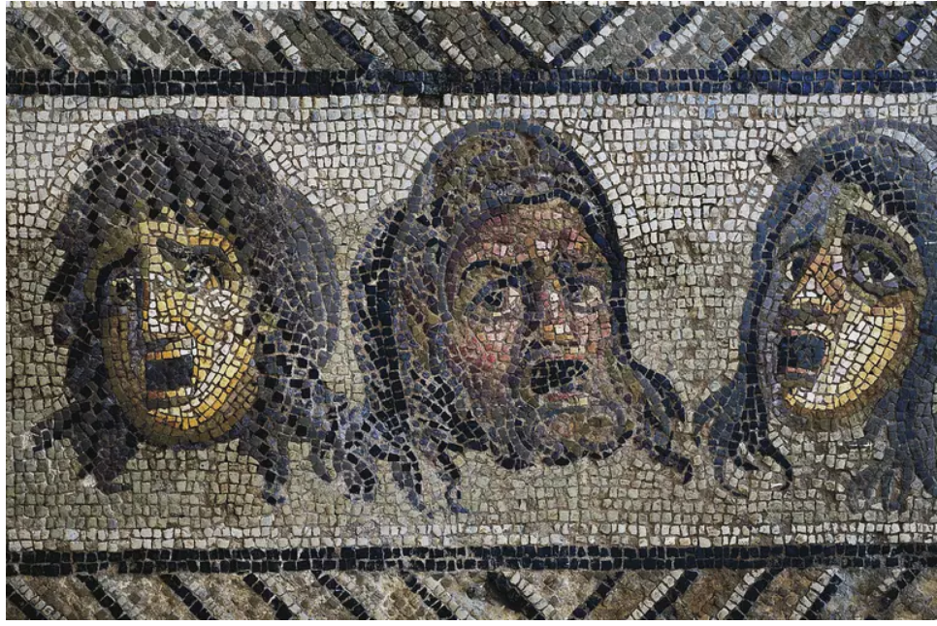

**Department of English Language and Literature, Faculty of Humanities, Razi University**

**An Introduction to Literature in English (II)-Drama**

**Fall Semester, September 2020- January 2021.**

**Class Meeting Days/Times: Tuesdays/10:00 p.m.-12:00 a.m.**

**Instructor:** Ghaderi, A.

**Email:** [ali.ghaderi988@yahoo.com](mailto:ali.ghaderi988@yahoo.com)

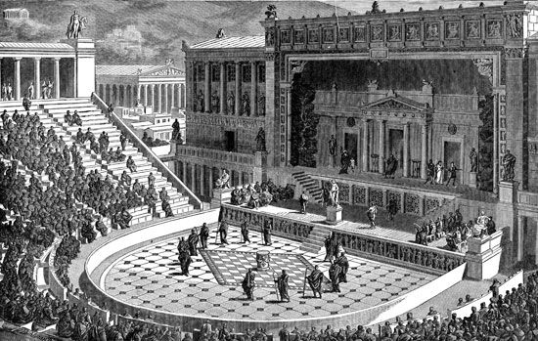

The Theatre of Dionysus in Athens (under the Romans)

**Course Overview:**

This course offers a brief survey into the nature and history of drama in the western tradition with emphasis put on the art’s history and essence in English literature and culture. Hopefully, the course will enhance the student’s understanding of the special nature of drama as a genre, and of its variety and power. It offers detailed critical appreciation of the nature and effectiveness of dramatic methods within a number of great plays, selected from a range of different cultures and historical periods; from ancient Greece to contemporary Europe. During the course, the students will master a critical understanding of major terms - tragedy, comedy, poetic drama, naturalist theatre, and so on. This understanding will come from reading the plays and watching a few notable performances of pivotal plays in the western tradition. Thus, the abstractions of general theories and terms will be accompanied by practicality of performances and textual analysis. The plays have been chosen according to their connection to the terms and concepts under discussion in each session. Moreover, the textbook’s content, theory or play, will serve as our primary source for texts and knowledge. Student are encouraged to compare and contrast different theatrical methods, terms, dramatic strategies, and of course, plays. While the main concern of this introductory course is not history of English drama and lives of the playwrights, historical facts, relations and development will be discussed whenever the necessity rises.

*“With a capacity of 32,000, the Roman theatre in Ephesus is still used for concerts and special events.*

*The modern proscenium theater has its historical origins in the classic Greek civilization. Fortunately for us, archaeological remains and the documents related to many of the Greek theaters are intact and well worth visiting.”*

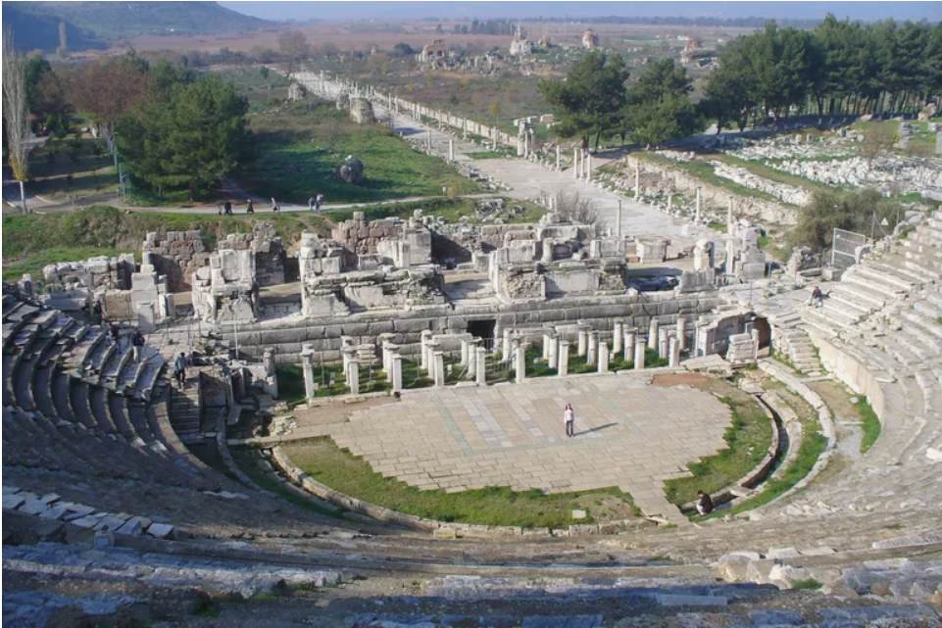

**Objectives:**

* Introducing the nature and function of drama in the western tradition
* Introducing technical elements, terms and subgenres of drama
* Reviewing famous examples of plays’ texts
* Analyzing stage performances of notable texts
* Introducing history of drama and theater in the western tradition
* Presenting methods and strategies in analyzing the content and structure of a given play

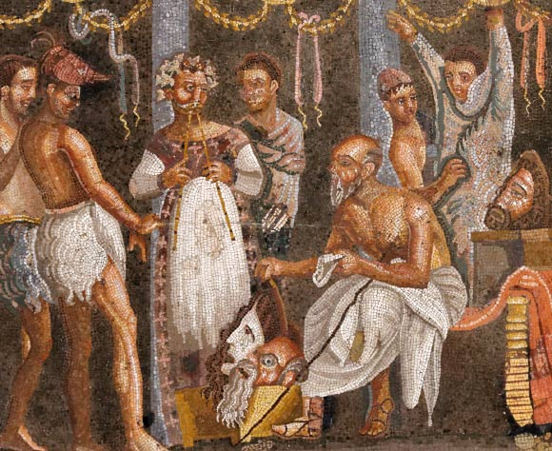

Roman mosaic in Pompeii. Image credit: Marie-Lan Nguyen

**Students’ Responsibilities and Required Assignments:**

* **Attendance:** Students are expected to attend all scheduled classes and to have completed the assigned reading before arriving in class. Two absences will be permitted. Each additional absence will result in a reduction of the final course grade.
* **Participation:** Students are expected to take part in class discussions and raise questions, if they have any, regarding the subject matter and content of each session. Moreover, they will be asked to give their opinion on certain matters during the class time.
* **Policies**

Attendance and participation are mandatory. Students must have the texts under discussion on them during the sessions (electronic editions and hardcopies are both acceptable). For the use of electronic editions look at classroom rules section.

The class is open to any reasonable criticism or suggestion. First and foremost, this course and our energy and time are to be employed to make sure that learning will occur, and you will finish this course with relative satisfaction having achieved a minimum though sufficient amount of literary and critical understating in accordance to your needs and interests. Hence, please share your concerns with the class or the instructor anytime the necessity arises.

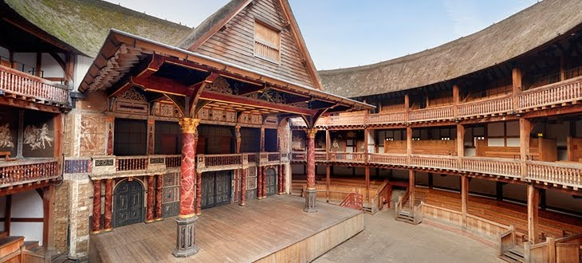

The marvelous stage of the Majestic Globe

**Classroom Rules**

* All electronic gadgets must be off or set to silent mode. If you use them for reading PDFs and other class related files, make sure they will not distract you or others so as to prevent the class from digressions.
* Punctuality is a non-negotiable must.
* 3 sessions of absence mean reducing your chance of passing the course greatly not to mention increasing the possibility of being dropped out of the course. Don’t try it, ever!
* Class activities are expected of the students.
* Last but not least, respect the class. Do not leave the class in groups during the breaks. You absolutely must not extend breaks’ duration on your own authority. For each session, a 10 minute break is already scheduled.
* Should the students have any questions, concerns, or requests for meeting and materials, they will contact me **only and solely** via my email address. Other forms of communications are absolutely not recommended.

You all have my thanks and appreciation since you have always observed these rules and regulations during your presence at classes. Bringing them here again is only a matter of formality and academic regulations.

**Schedule:**

**Session 1:**

The nature of drama, definitions, roots and origins

**Session 2:**

Stage, character and dialogue, historical development of drama, Sophocles, *Antigone* (self-study)

**Session 3:**

‘Realistic and Nonrealistic Drama’, *Everyman* (self-study), Greek drama I

**Session 4:**

Greek drama II, Aristotelian theory of drama

**Session 5:**

‘Tragedy and Comedy’, William Shakespeare *Othello*

**Session 6:**

Religion and Tragedy, Sophocles*, Oedipus Rex* I

**Session 7:**

Sophocles*, Oedipus Rex* II

**Session 8:**

Philosophy and tragedy, Introduction to modern drama I, Arthur Miller, *The Crucible* I

**Session 9:**

Introduction to modern drama II, Arthur Miller, *The Crucible* II

**Session 10:**

Arthur Miller, *The Crucible* III

**Session 11:**

Contemporary drama: a brief introduction

**Session 12:**

Review

**Extra Sessions: Renaissance Drama: *The Twelfth Night* and *Dr. Faustus***

**Resources:**

Perrine, Laurence. *Literature: Drama*. Thomson, 2006.

Watson, George. *Drama, an Introduction*. St. Martins Press, 1985.

**Grading and Evaluation:**

Participation and analysis of the works on class’s agenda are expected of the students.

**Your final grade will be decided based on:**

Class participation → 30 per cent

Critical Response Papers→ 40*

Final exam** → 30 per cent

*On sessions 7th and 13th, two questions are raised by the instructor. Each student must respond to the questions in form of short essays. I will not dictate the length of your writings. You are free to compose at any length that will deliver your response **clearly** and **logically**. Demonstrating **critical insight** and **precision** in the argument are expected of you.

\***\***the final exam will be an essay exam. On your exam, you will answer essay questions that are structured around the issues discussed in the class. You must respond to them properly and to the point in a reasonable length with maximum awareness of the texts themselves and critical subject matters that have been presented in the class. It goes needless to say that those who show genuine analytical insights in their answers will receive extra points. And there will be at least one bonus question on your exam which is much more difficult than the regular questions and needs a great deal of critical insight and mastery over the sources. Don’t forget: **everything I say will be on the exam!**

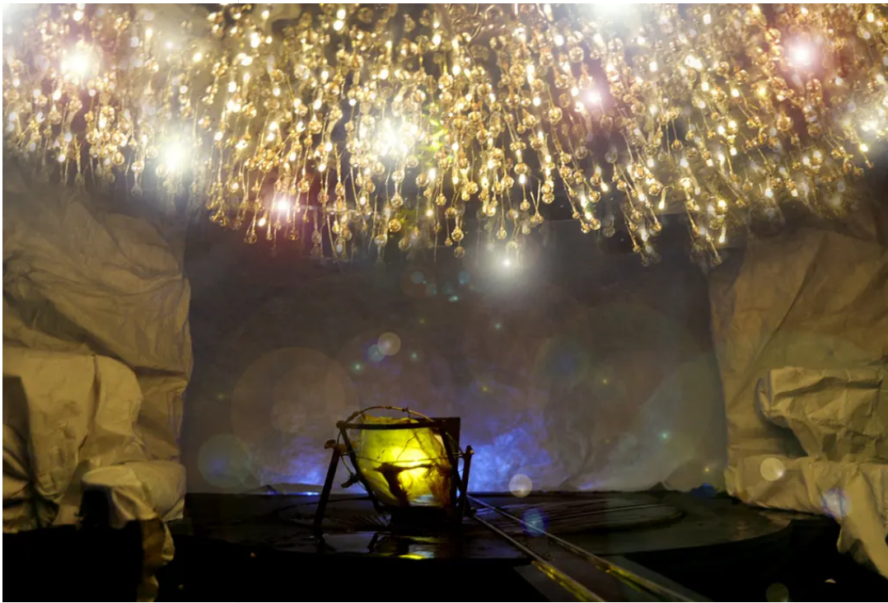

Mark Tildesley’s model design for Frankenstein, showing the Creature about to be born. Photograph: National Theatre